Prolog Program for a Database with NAME and DOB
Aim
To create a Prolog database containing a person's name and date of birth and retrieve the information using queries.
Objectives
- To understand facts in Prolog.
- To create a simple database.
- To retrieve information using queries.
Algorithm
- Start.
- Define facts containing name and date of birth.
- Create a rule to retrieve the DOB.
- Enter a name as a query.
- Display the corresponding date of birth.
- Stop.
Flowchart
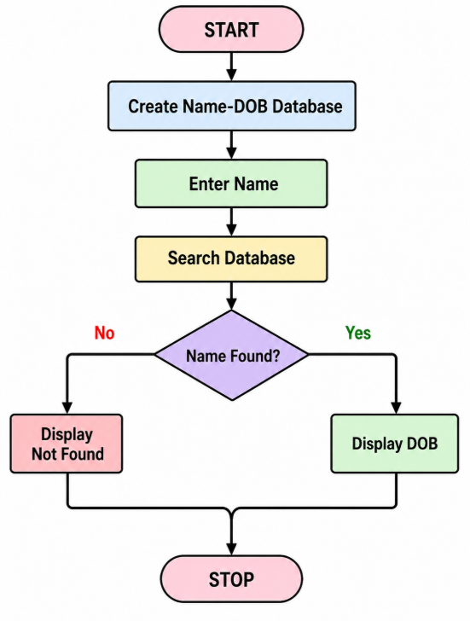

PROGRAM

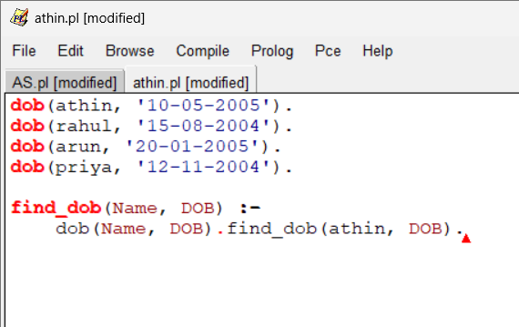
OIUTPUT
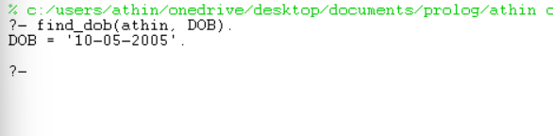

Result
The Prolog database was successfully created and the date of birth was retrieved using the person's name.

